**2K Course**

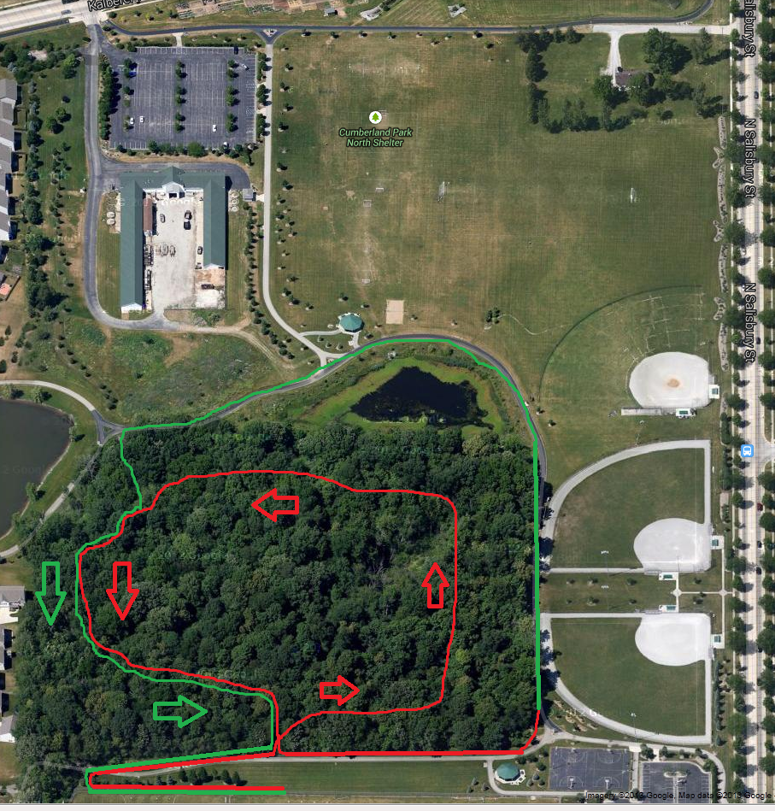

**2K Course**

**Red = 1K**

**Green = 2K**